**LAB-1**

**Q1. Write a program to show the difference between various heading tags. Make the font-size of “h1” heading 100px explicitly, and rest of the headings same as their default size.**

* <!DOCTYPE html>
* <html lang="en">
* <head>
* <meta charset="UTF-8">
* <meta http-equiv="X-UA-Compatible" content="IE=edge">
* <meta name="viewport" content="width=device-width, initial-scale=1.0">
* <title>Heading Tags</title>
* <style>
* h1{
* font-size: 100px;
* }
* </style>
* </head>
* <body>
* <h1>Heading 1 (100px)</h1>
* <h2>Heading 2</h2>
* <h3>Heading 3</h3>
* <h4>Heading 4</h4>
* <h5>Heading 5</h5>
* <h6>Heading 6</h6>
* </body>
* </html>

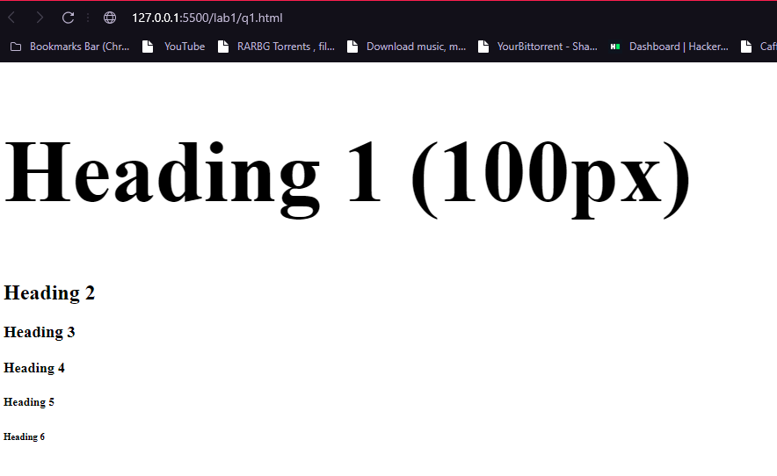

**Q2. Write a program to display the following in the middle of the Html document using suitable Html tag, except the center tag.**

*

***

*****

*******

*********

<!DOCTYPE html>

<html lang="en">

<head>

    <meta charset="UTF-8">

    <meta http-equiv="X-UA-Compatible" content="IE=edge">

    <meta name="viewport" content="width=device-width, initial-scale=1.0">

    <title>Ques 2</title>

</head>

<body>

    <div>

      <pre style = "text-align: center;">

          *

          ***

          *****

          *******

          *********

          ***********

      </pre>

    </div>

</body>

</html>

* 

**LAB-2**

**Q1. a. Make a web page to include two Html links. Assume the link text yourself. On click of both the links, Google.com should open. But, on the click of first link, Google.com should open in the same tab, whereas on the click of second link, Google.com should open in a new tab.**

**b. Use Html links to send an email to me at btech.cse5.webtech@gmail.com, with a subject “Assignment” and the message text as “Submitted”.**

<!DOCTYPE html>

<html lang="en">

<head>

    <meta charset="UTF-8">

    <meta http-equiv="X-UA-Compatible" content="IE=edge">

    <meta name="viewport" content="width=device-width, initial-scale=1.0">

    <title>Lab 2 Q1</title>

    <style>

        #first,#second{

            font-size: 3rem;

            margin: 5rem 10rem;

            display: block;

            text-decoration: none;

            color: lightcoral;

        }

        #first:hover,#second:hover{

            text-decoration: underline;

        }

        div{

            font-size: 1rem;

        }

        #email{

            font-size: 2rem;

            margin-left: 10rem;

            text-decoration: none;

            color: black;

        }

        #email:hover{

            text-decoration: underline;

        }

    </style>

</head>

<body>

    <!--  -->

    <a id = "first" href="https://google.com">Google</a>

    <a id ="second" href="https://google.com" target = "__blank"> WOW! Google <div>(opens in new Tab)</div></a>

    <a id = "email" href="mailto:btech.cse5.webtech@gmail.com?subject=Assignment&body=Submitted" target = "__blank">Email ME</a>

</body>

</html>

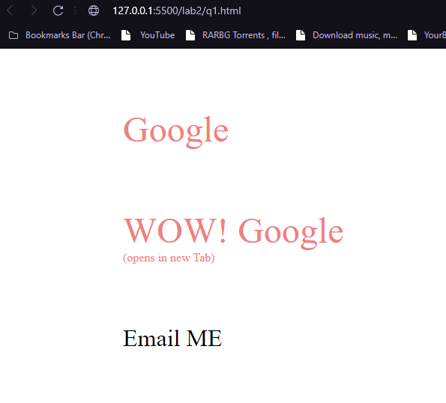

**On clicking “Email ME” button:**

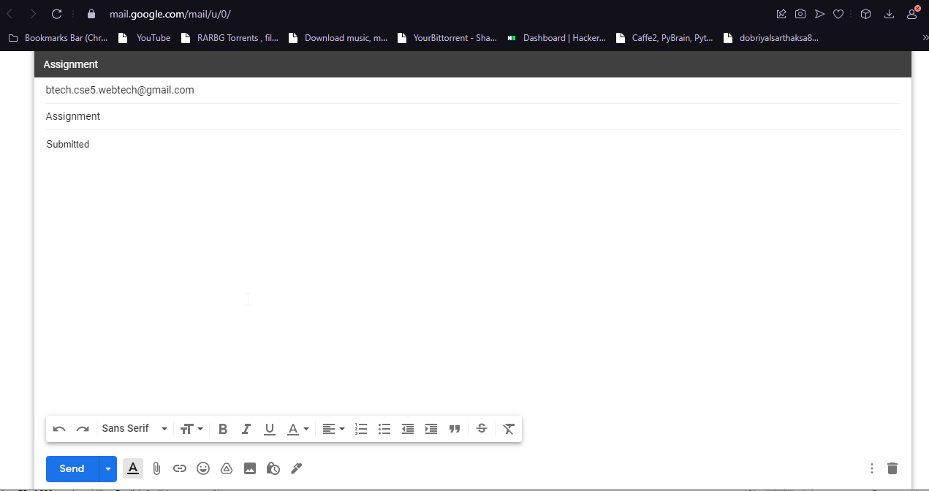

**Q2. Take an image of the Indian map, and make any three states clickable using image maps. Perform different functions on the click of each state.**

<!DOCTYPE html>

<html lang="en">

<head>

    <meta charset="UTF-8">

    <meta http-equiv="X-UA-Compatible" content="IE=edge">

    <meta name="viewport" content="width=device-width, initial-scale=1.0">

    <title>Image Links</title>

    <style>

        body{

            background-color: darkslategrey;

            margin: 0;

        }

    </style>

</head>

<body>

    <img src="./mapIndia.jpg" alt="Indian Map" usemap="#india">

    <map name="india">

        <area shape="poly" coords="234, 177, 245, 187, 251, 186, 258, 190, 272, 203, 255, 232, 231,228,233,219,219,213,209,214,209,201,213,184,232,182 " href="./uttarakhand.jpg" alt="uttarakhand">

        <area shape="poly" coords="133,207,148,212,154,226,163,225,,178,257,194,252,196,260,201,269,216,279,185,302,202,314,186,332,160,317,146,354,81,324,66,298,53,276,72,253,96,256" href="./rajasthan.png" alt="">

        <area shape="poly" coords="184,587,208,583,212,564,259,559,250,610,235,631,215,651,201,657,201,624" href="./tamil.gif" alt="">

    </map>

</body>

</html>

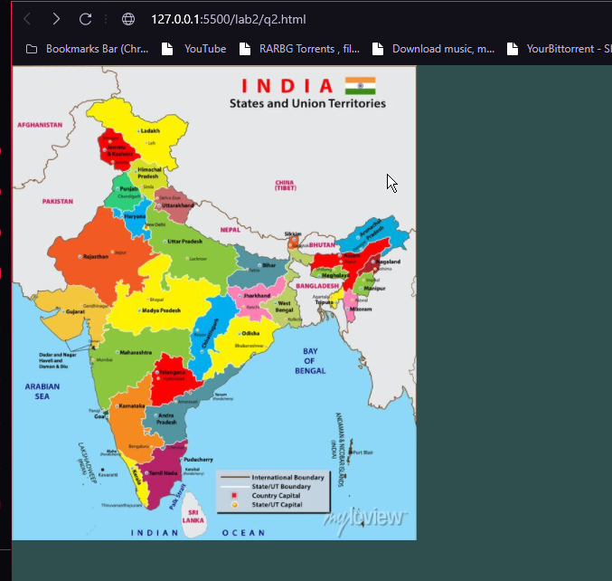

**On clicking Uttarakhand opens District Map of Uttarakhand:**

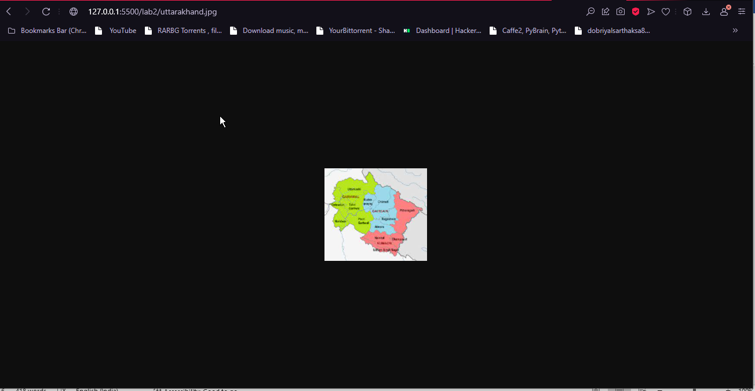

**On clicking Rajasthan opens District Map of Rajasthan:**

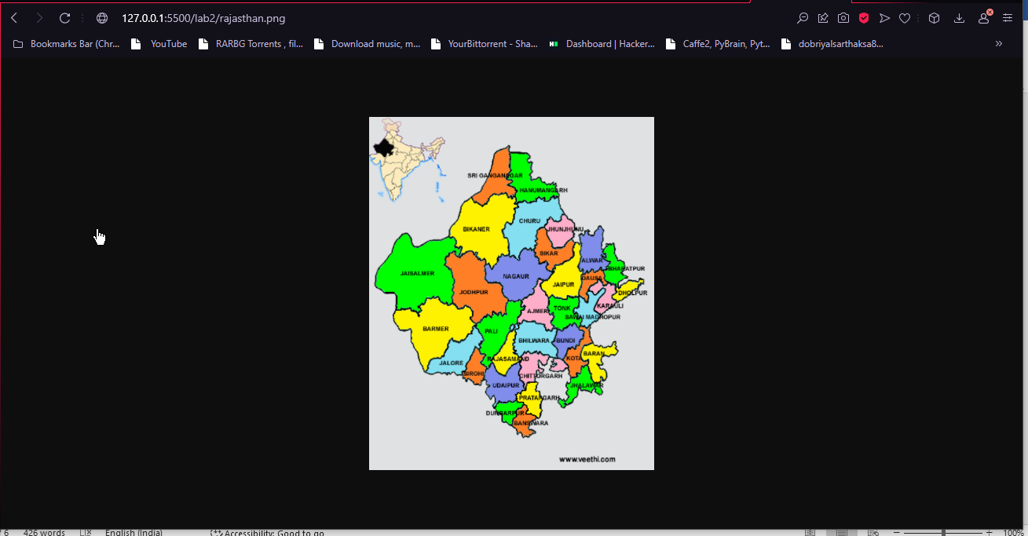

**LAB-3**

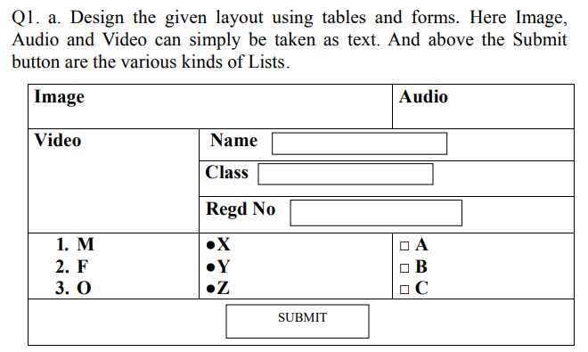

<!DOCTYPE html>

<html lang="en">

<head>

    <meta charset="UTF-8">

    <meta http-equiv="X-UA-Compatible" content="IE=edge">

    <meta name="viewport" content="width=device-width, initial-scale=1.0">

    <title>Graphic Era Hill University

    </title>

    <style>

        table {

            border-collapse: collapse;

            margin-left: 375px;

        }

        td{

            text-align: left;

        }

        th,td{

            border: 1px solid black;

            padding: 8px 116px 5px 2px;

        }

        button{

            padding: 5px 40px;

            margin-left: 190px;

            background-color: white;

            border: 0.5px solid;

        }

        h1{

            margin-left: 585px;

        }

    </style>

</head>

<body>

    <h1>Table</h1>

    <table>

        <thead>

            <tr>

                <th colspan="2">Image</th>

                <th colspan="1">Audio</th>

            </tr>

        </thead>

        <tbody>

            <tr>

                <td rowspan="3">Video</td>

                <td colspan="2">

                    Name: <input type="text">

                </td>

            </tr>

            <tr>

                <td colspan="2">Class: <input type="text"></td>

            </tr>

            <tr>

                <td colspan="2">Regd No: <input type="text"></td>

            </tr>

            <tr>

                <td>

                    <ol>

                        <li>M</li>

                        <li>F</li>

                        <li>O</li>

                    </ol>

                </td>

                <td>

                    <ul>

                        <li>X</li>

                        <li>Y</li>

                        <li>Z</li>

                    </ul>

                </td>

                <td>

                    <ul type="square">

                        <li>A</li>

                        <li>B</li>

                        <li>C</li>

                    </ul>

                </td>

            </tr>

            <tr >

                <td colspan="3">

                    <button>

                        SUBMIT

                    </button>

                </td>

            </tr>

        </tbody>

    </table>

</body>

</html>

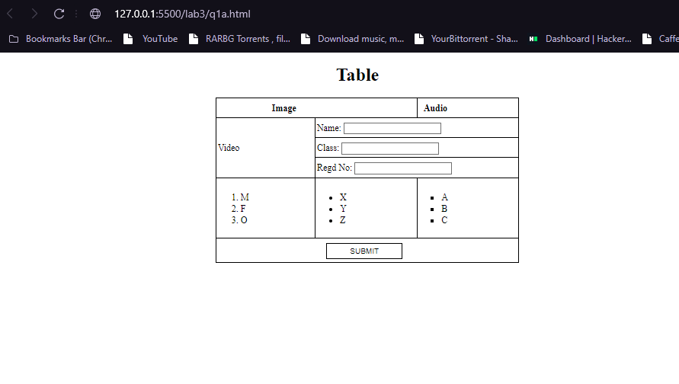

**b. Create an HTML5 page with following specifications:**

**- Browser tab should display “Graphic Era Hill University, Dehradun”.**

**- “Graphic Era Hill University, Dehradun” should be the page heading.**

**- A section containing the heading “Overview”, where few lines about the college are mentioned.**

**- A section with the heading “Courses Offered”, where few courses offered by college are mentioned as a list. Create subcourses too.**

**- A section mentioning Course and corresponding fees in tabular format. SUBMIT**

**- A section containing college image of size 500*300.**

**- A section to display advertisement.**

**- A section containing copyright information and year (both mentioned in italics).**

<!DOCTYPE html>

<html lang="en">

<head>

    <meta charset="UTF-8">

    <meta http-equiv="X-UA-Compatible" content="IE=edge">

    <meta name="viewport" content="width=device-width, initial-scale=1.0">

    <title>Graphic Era Hill University Dehradun</title>

    <style>

        body{

            margin: 0px;

        }

        h2{

            text-shadow: 2px 2px limegreen;

            text-decoration: underline;

            margin: 0px;

            font-size: 3rem;

            text-align: center;

            color: black;

        }

        .overview{

            margin-top: 800px;

            background-color: lightpink ;

            padding: 1rem;

            color: black;

        }

        .course{

            margin-top: 0px;

            background-color: aquamarine ;

            padding: 2rem;

            height: fit-content;

            display: flex;

            justify-content: space-around;

        }

        p{

            font-size: 1.5rem;

            line-height: 2rem;

            color: balck;

            text-align: center;

            line-height: 2.5rem;

        }

        h3{

            text-shadow: 2px 2px white;

            font-size: 2rem;

            text-align: center;

            text-decoration: underline;

        }

        .bachelors .big,.masters .big{

            font-size: 1.5rem;

            font-weight: bold;

            line-height: 2.5rem;

        }

        .bachelors{

            border: 1px solid black;

            border-radius: 3rem;

            padding: 1rem;

            width: 40%;

            height: fit-content;

        }

        .masters{

            border: 1px solid black;

            border-radius: 2rem;

            padding: 1rem;

            width: 40%;

            height: 685px;

        }

        .dept{

            font-weight: 100;

        }

        .fee{

            text-align: center;

            padding: 2rem;

            font-size: 2rem;

        }

        th,td{

            border: 1px solid;

            padding: 1rem;

        }

        table{

            margin-top: 2rem;

            margin-left: 19rem;

            border-collapse:collapse;

        }

        footer{

            background-color: black;

            color: white;

            padding: 1rem;

            text-align: center;

            font-size: 1.5rem;

            font-style: italic;

        }

        img{

            height: 500px;

            width: 100%;

        }

        h1{

            font-size: 3rem;

            text-align: center;

            color: white;

            text-shadow: 5px 5px black;

        }

        .text{

            margin:-400px

        }

        .image{

            height: 400px;

        }

        .dept{

            font-style: italic;

        }

    </style>

</head>

<body>

    <div class="image">

        <img src="./mainphoto.jpeg" alt="graphic era hill university campus" >

    </div>

        <div class="text">

            <h1>Graphic Era Hill University Dehradun</h1>

        </div>

    <div class = "overview">

        <h2>Overview</h1>

        <p>

            Established vide Act No 12 of 2011 of Uttarakhand State Legislature

University under Section 2(f) of the UGC Act, 1956 set up under the aegis of Graphic Era Educational Society, Dehradun. Founded in 2011 Graphic Era Hill University is today widely known for its innovative and rigorous education which has nurtured professionals across industries and sectors in India and beyond. Graphic Era Hill University has adopted a global approach to education and research with focus on International perspectives and expertise. University has abiding commitment to excellence and pursues this relentlessly settling for nothing, but the best. Its faculty is the bedrock of the University and composed of academic luminaries across India and abroad. GEHU is on the cutting edge of using state-of-the art equipment and preparing students for globalized economy and at the same time promoting holistic learning, unbiased knowledge ,industry centric skills, ethics, a cosmopolitan outlook and accountability for actions. GEHU is making its presence at national and international platforms, through collaborations with premier universities of the world, study abroad programs and international internships and research.

Graphic Era Hill University offers comprehensive curriculum over a large number of degree programs in engineering, law, management, computer applications, humanities, applied sciences, animation, fashion designing, journalism and mass communication, Agriculture. These programs offer the students multiple academic pathways. The University has an abiding commitment to create excellent education opportunities for the youth hailing from the hills, at affordable cost. Therefore 25% concession in the fee is offered to the students of hill areas, across the country. University also offers unstinting support for community services, through its social responsibility endeavors.

        </p>

    </div>

    <h2 class="course">Courses Offered</h2>

    <div class="course">

        <div class="bachelors">

            <h3>Undergraduate Courses</h3>

            <ul class="big">

                <li>Bachelors of Technology

                    <ul type="square" class="dept">

                        <li>Computer Science</li>

                        <li>Mechanical</li>

                        <li>Civil</li>

                        <li>Electrical</li>

                    </ul>

                </li>

                <li>Bachelors of Computer Application</li>

                <li>Bachelors of Commerce</li>

                <li>Bachelors of Science

                    <ul type="square" class="dept">

                        <li>Mathematics</li>

                        <li>Physics</li>

                        <li>Chemistry</li>

                    </ul>

                </li>

                <li>Bachelors of Agricultural Sciences</li>

                <li>Bachelors of Business Administration</li>

                <li>Hotel Management</li>

            </ul>

        </div>

        <div class="masters">

            <h3>Post-Graduate Course</h3>

            <ul class="big">

                <li>Masters of Technology

                    <ul type="square" class="dept">

                        <li>Computer Science</li>

                        <li>Mechanical</li>

                        <li>Civil</li>

                        <li>Electrical</li>

                    </ul>

                </li>

                <li>Masters of Business Administration</li>

                <li>Masters of Commerce</li>

                <li>Masters of Computer Application</li>

                <li>Masters of Sciences

                    <ul type="square" class="dept">

                        <li>Mathematics</li>

                        <li>Physics</li>

                        <li>Chemistry</li>

                    </ul>

                </li>

                <li>Masters of Arts</li>

                <li</li>

            </ul>

        </div>

    </div>

    <div class="fee">

        <h2>Fees Structure</h2>

        <table>

            <thead>

            <tr>

            <th>Course</th>

            <th>Duration</th>

            <th>Fees

            </th>

            </tr>

            </thead>

            <tbody>

            <tr>

            <td>B.Arch [Bachelor of Architecture]</td>

            <td>5 Years </td>

            <td>₹11.35 Lakh</td>

            </tr>

            <tr>

            <td>BBA [Bachelor of Business Administration]</td>

            <td>3 Years </td>

            <td>₹4.71 Lakh</td>

            </tr>

            <tr>

            <td>B.Com [Bachelor of Commerce]</td>

            <td>3 Years </td>

            <td>₹4.09 Lakh</td>

            </tr>

            <tr>

            <td>BCA [Bachelor of Computer Application]</td>

            <td>3 Years </td>

            <td>₹3.51 Lakh</td>

            </tr>

            <tr>

            <td>BE [Bachelor of Engineering]</td>

            <td>2 Years </td>

            <td>₹56,020 </td>

            </tr>

            <tr>

            <td>BFA [Bachelor of Fine Arts]</td>

            <td>4 Years </td>

            <td>₹5.89 Lakh</td>

            </tr>

            <tr>

            <td>B.Tech [Bachelor of Technology]</td>

            <td>4 Years </td>

            <td>₹9.97 Lakh</td>

            </tr>

            <tr>

            <td>MCA [Master of Computer Application]</td>

            <td>2 Years </td>

            <td>₹3.85 Lakh</td>

            </tr>

            <tr>

            <td>BA [Bachelor of Arts]</td>

            <td>3 Years </td>

            <td>₹3.24 Lakh</td>

            </tr>

            <tr>

            <td>B.Des [Bachelor of Design]</td>

            <td>4 Years </td>

            <td>₹6.33 Lakh</td>

            </tr>

            <tr>

            <td>B.Sc [Bachelor of Science]</td>

            <td>3 Years </td>

            <td>₹3.59 Lakh</td>

            </tr>

            <tr>

            <td>MA [Master of Arts]</td>

            <td>2 Years </td>

            <td>₹1.98 Lakh</td>

            </tr>

            <tr>

            <td>MBA [Master of Business Administration]</td>

            <td>2 Years </td>

            <td>₹4.39 Lakh</td>

            </tr>

            <tr>

            <td>M.Com [Master of Commerce]</td>

            <td>2 Years </td>

            <td>₹1.97 Lakh</td>

            </tr>

            <tr>

            <td>M.Sc [Master of Science]</td>

            <td>2 Years </td>

            <td>₹1.97 Lakh</td>

            </tr>

            <tr>

            <td>M.Tech [Master of Technology]</td>

            <td>2 Years </td>

            <td>₹2.46 Lakh</td>

            </tr>

            <tr>

            <td>BMS [Bachelor of Management Studies]</td>

            <td>2 Years </td>

            <td>₹56,020 </td>

            </tr>

            </tbody>

            </table>

    </div>

    <footer>Graphic Era Hill University © 2022</footer>

</body>

</html>

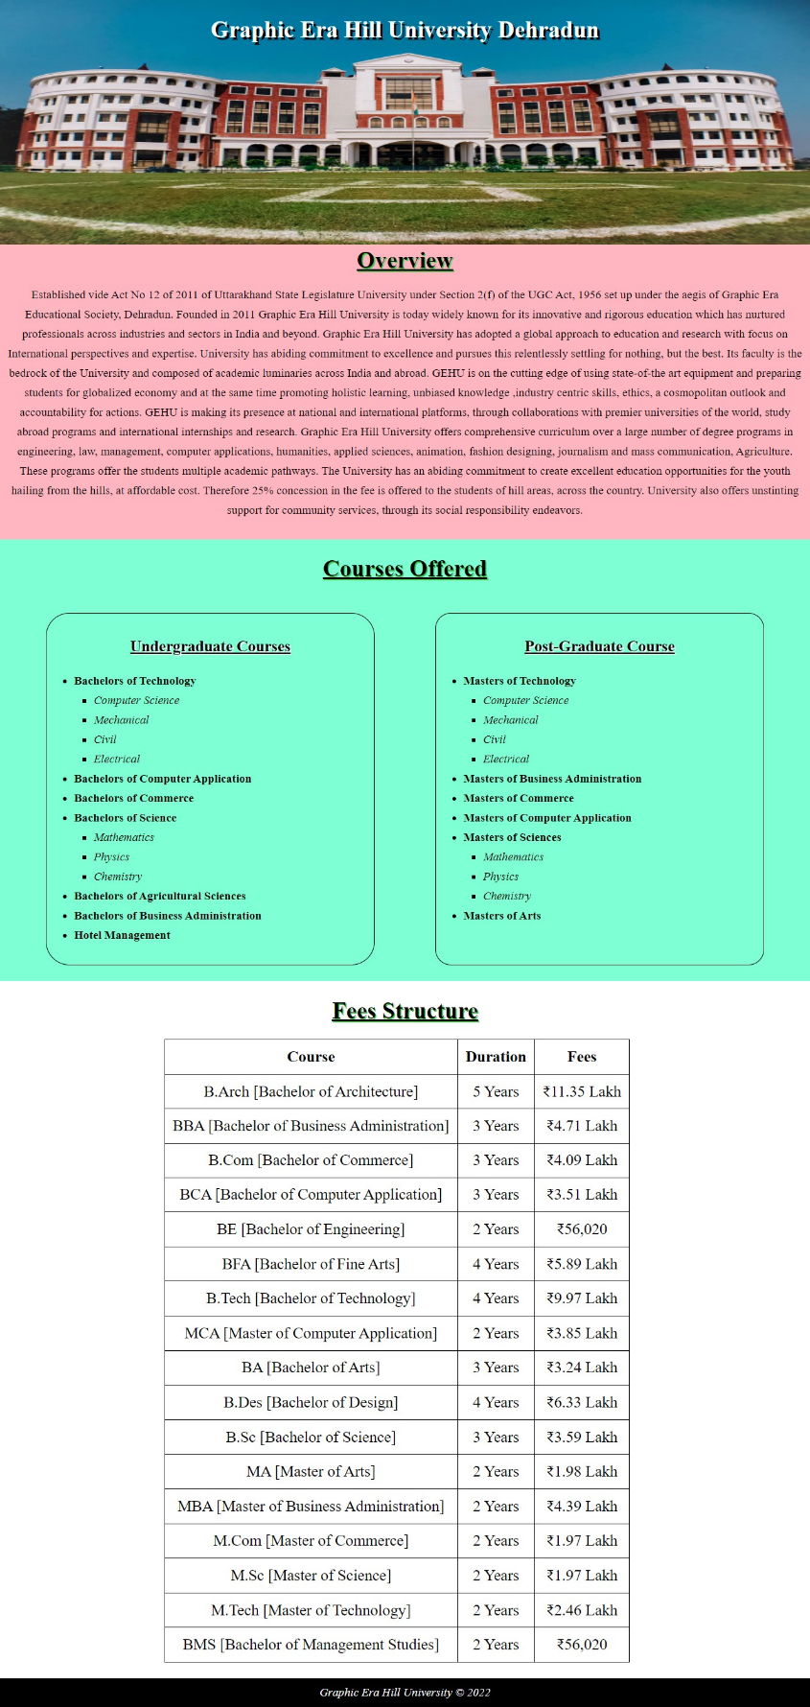

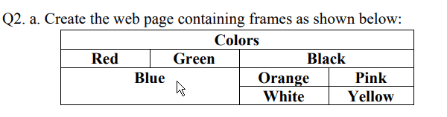

<!DOCTYPE html>

<html lang="en">

<head>

    <meta charset="UTF-8">

    <meta http-equiv="X-UA-Compatible" content="IE=edge">

    <meta name="viewport" content="width=device-width, initial-scale=1.0">

    <title>table colors</title>

    <style>

        td{

            color: white;

        }

        table{

            border-collapse: collapse;

        }

        td,th{

            border: 1px solid black;

            padding: 0rem 1.5rem;

        }

        #red{

            background-color: red;

        }

        #Green{

            background-color: Green;

        }

        #Black{

            background-color: Black;

        }

        #Blue{

            background-color: Blue;

        }

        #Orange{

            background-color: Orange;

        }

        #Pink{

            background-color: Pink;

        }

        #White{

            background-color: white;

            color: black;

        }

        #Yellow{

            background-color: Yellow;

        }

        table{

          margin  :  1rem 28rem 0rem ;

            padding: 2rem;

        }

        h1{

            font-size: 2rem;

            margin: 2rem 0rem 0rem 30rem;

    }

    </style>

</head>

<body>

    <h1>COLORED TABLE</h1>

    <table>

        <thead>

            <tr >

                <th colspan="4"> Colors</th>

            </tr>

        </thead>

        <tbody>

            <tr>

                <td id="red">Red</td>

                <td id="Green">Green</td>

                <td colspan="2" id="Black">Black</td>

            </tr>

            <tr>

                <td colspan="2" rowspan="2" id="Blue">Blue</td>

                <td id="Orange">Orange</td>

                <td id="Pink">Pink</td>

            </tr>

            <tr>

                <td id="White">White</td>

                <td id="Yellow">Yellow</td>

            </tr>

        </tbody>

    </table>

</body>

</html>

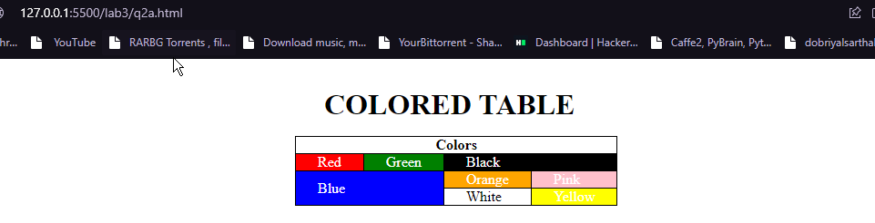

**b. Write a program to show the working of audio and video tags, with all it’s attributes**

<!DOCTYPE html>

<html lang="en">

<head>

    <meta charset="UTF-8">

    <meta http-equiv="X-UA-Compatible" content="IE=edge">

    <meta name="viewport" content="width=device-width, initial-scale=1.0">

    <title>Audio and Video Tags</title>

    <style>

        *{

            font-size: 1.5rem;

            margin-left: 10px

            ;

        }

    </style>

</head>

<body>

    <div class="audios">

        <label for="Autoplay">Autoplay:</label>

        <audio src="./file_example_MP3_700KB.mp3" id="Autoplay" controls  autoplay></audio>

    <div class="audios">

        <label for="loop">Loop:</label>

         <audio src="./file_example_MP3_700KB.mp3" id="loop" controls loop ></audio>

    <div class="audios">

        <label for="muted">Muted:</label>

        <audio src="./file_example_MP3_700KB.mp3" id="muted" controls muted ></audio>

    </div>

    <label for="video">Video:</label>

    <div id="video">

        <video src="./videoplayback.mp4" controls width="40%" height="40%"></video>

    </div>

</body>

</html>

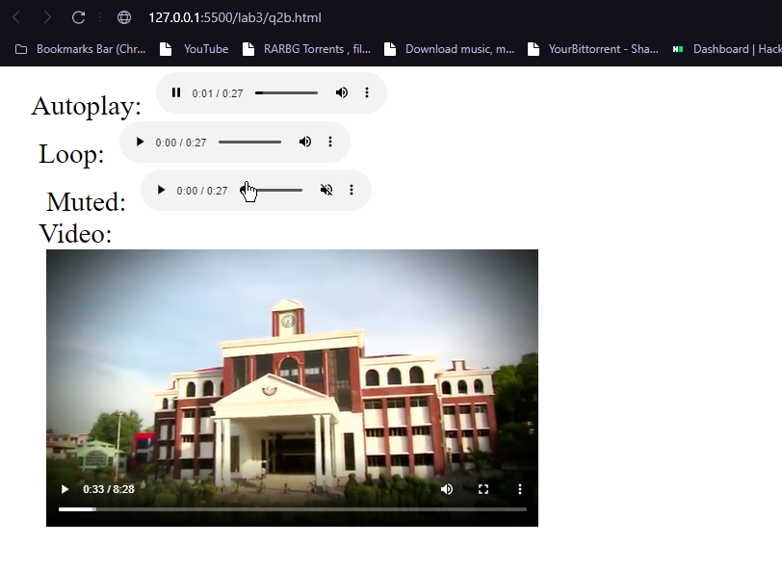

**LAB-4**

**Q1. Write a program to make a navigation bar, containing the links Home, About us, Portfolio, and Contact us and style it using css with colors and background colors and suitable and equal spaces between the links.**

<!DOCTYPE html>

<html lang="en">

<head>

    <meta charset="UTF-8">

    <meta http-equiv="X-UA-Compatible" content="IE=edge">

    <meta name="viewport" content="width=device-width, initial-scale=1.0">

    <title>NavBar</title>

    <style>

        body{

            margin: 0px;

            padding: 0px;

        }

        nav{

            background-color: black;

            padding: 2rem;

        }

        ul{

            margin: 0px;

            text-align: left ;

            font-size: 1.3rem;

            display: inline;

        }

        ul li{

            list-style: none;

            display: inline;

            padding: 1rem;

        }

        ul li a{

            text-decoration: none;

            color: lightslategrey;

        }

        div{

            display: inline;

            position: relative;

            right: -500px;

            padding: 0.5rem;

            border: 1px solid white;

            background-color: white;

            border-radius: 1rem;

        }

        input{

            border: none;

            outline: none;

            color: black;

            height: 1rem;

            padding: 0.4rem;

        }

    </style>

</head>

<body>

    <nav>

        <ul>

            <li><a href="#">Home</a></li>

            <li><a href="#">About Us</a></li>

            <li><a href="#">PortFolio</a></li>

            <li><a href="#">Contact Us</a></li>

        </ul>

        <div class=" search">

            <input type="text" name="search" id="" placeholder="Search">

        </div>

    </nav>

</body>

</html>

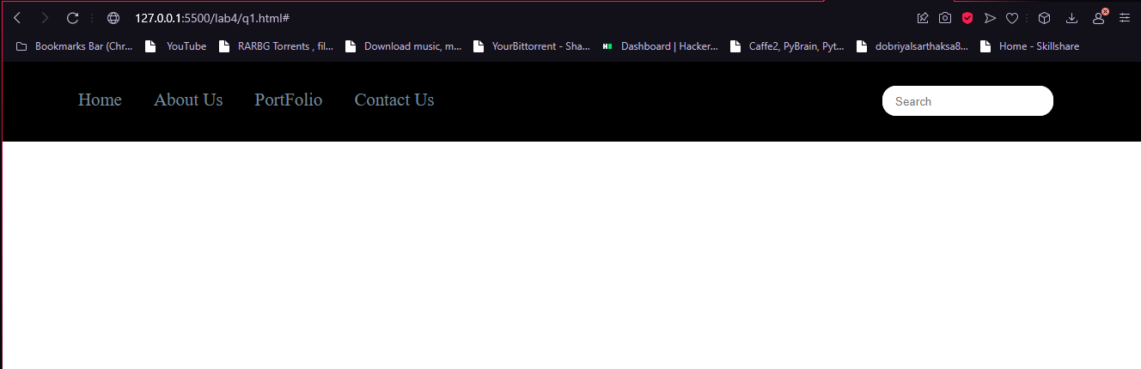

**Q2. Write a program to show the working of all the states of CSS Links: link, visited, hover and active.**

<!DOCTYPE html>

<html lang="en">

<head>

    <meta charset="UTF-8">

    <meta http-equiv="X-UA-Compatible" content="IE=edge">

    <meta name="viewport" content="width=device-width, initial-scale=1.0">

    <title>Anchor Tags</title>

    <style>

        body{

            margin: 0px;

            padding: 0px;

        }

        nav{

            background-color: black;

            padding: 2rem;

            text-align: center ;

        }

        ul{

            margin: 0px;

            font-size: 1.3rem;

            display: inline;

        }

        ul li{

            list-style: none;

            display: inline;

            padding: 1rem;

        }

        ul li a{

            text-decoration: none;

            color: lightslategrey;

        }

        ul li a:hover{

            text-decoration: underline;

        }

        a:active{

            font-size: 35px;

        }

        a:visited {

            color: violet;

        }

        </style>

</head>

<body>

    <nav>

        <ul>

            <li><a href="https://google.com">Google</a></li>

            <li><a href="https://youtube.com">Youtube</a></li>

            <li><a href="https://gmail.com">Gmail</a></li>

        </ul>

    </nav>

</body>

</html>



**Visited:**



**Q3. Write a program to style the table even rows with background-color yellow, and odd rows with background-color green on css hover property. Assume that the table contains thousands of rows.**

<!DOCTYPE html>

<html lang="en">

<head>

    <meta charset="UTF-8">

    <meta http-equiv="X-UA-Compatible" content="IE=edge">

    <meta name="viewport" content="width=device-width, initial-scale=1.0">

    <title>Table Colors</title>

    <style>

        table{

            border-collapse: collapse;

            margin-left: 30%;

        }

        th{

            font-size: 2rem;

            font-style: italic;

            background-color: black;

            color: white;

        }

        td,th{

            border: 1px solid;

            padding: 2rem;

            text-align: center;

            font-weight: bold;

        }

        tr:nth-child(even):hover{

            background-color: yellow;

            color: white;

        }

        tr:nth-child(odd):hover{

            background-color: green;

            color: white;

        }

    </style>

</head>

<body>

    <table>

        <thead>

            <tr>

                <th>lorem</th>

                <th>ipsum</th>

                <th>whimpsi</th>

            </tr>

        </thead>

        <tbody>

            <tr>

                <td>some data</td>

                <td>some data</td>

                <td>some data</td>

            </tr>

            <tr>

                <td>some data</td>

                <td>some data</td>

                <td>some data</td>

            </tr>

            <tr>

                <td>some data</td>

                <td>some data</td>

                <td>some data</td>

            </tr>

            <tr>

                <td>some data</td>

                <td>some data</td>

                <td>some data</td>

            </tr>

            <tr>

                <td>some data</td>

                <td>some data</td>

                <td>some data</td>

            </tr>

            <tr>

                <td>some data</td>

                <td>some data</td>

                <td>some data</td>

            </tr>

            <tr>

                <td>some data</td>

                <td>some data</td>

                <td>some data</td>

            </tr>

            <tr>

                <td>some data</td>

                <td>some data</td>

                <td>some data</td>

            </tr>

            <tr>

                <td>some data</td>

                <td>some data</td>

                <td>some data</td>

            </tr>

            <tr>

                <td>some data</td>

                <td>some data</td>

                <td>some data</td>

            </tr>

            <tr>

                <td>some data</td>

                <td>some data</td>

                <td>some data</td>

            </tr>

            <tr>

                <td>some data</td>

                <td>some data</td>

                <td>some data</td>

            </tr>

            <tr>

                <td>some data</td>

                <td>some data</td>

                <td>some data</td>

            </tr>

            <tr>

                <td>some data</td>

                <td>some data</td>

                <td>some data</td>

            </tr>

            <tr>

                <td>some data</td>

                <td>some data</td>

                <td>some data</td>

            </tr>

            <tr>

                <td>some data</td>

                <td>some data</td>

                <td>some data</td>

            </tr>

            <tr>

                <td>some data</td>

                <td>some data</td>

                <td>some data</td>

            </tr>

            <tr>

                <td>some data</td>

                <td>some data</td>

                <td>some data</td>

            </tr>

            <tr>

                <td>some data</td>

                <td>some data</td>

                <td>some data</td>

            </tr>

        </tbody>

    </table>

</body>

</html>

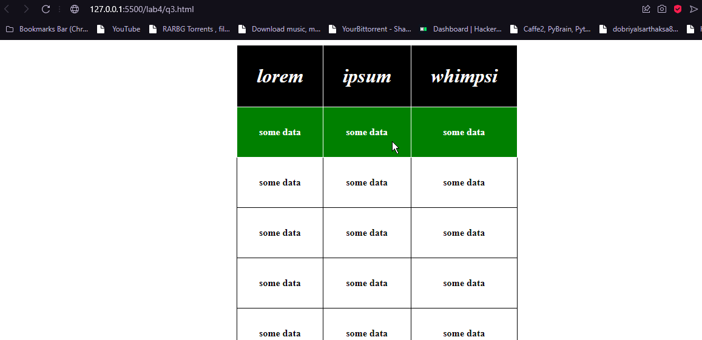

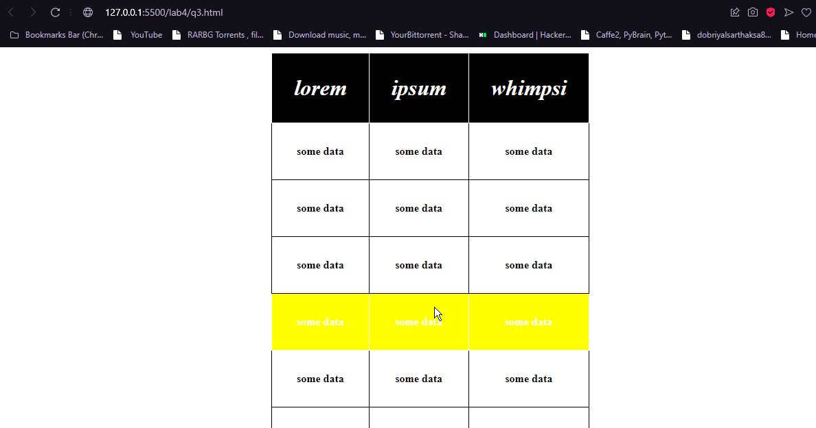

**Q4. Write a program to make an ordered and unordered lists and make thier item-markers as an image, and thier position outside.**

<!DOCTYPE html>

<html lang="en">

<head>

    <meta charset="UTF-8">

    <meta http-equiv="X-UA-Compatible" content="IE=edge">

    <meta name="viewport" content="width=device-width, initial-scale=1.0">

    <title>Lists</title>

    <style>

        body{

            margin-left: 2rem;

        }

        ul{

            font-size: 1.5rem;

            list-style-image: url('./apple.jpg');

            list-style-position: outside;

        }

           li{

               padding: 1rem 0rem;

           }

    </style>

</head>

<body>

    <h1>Types of Apples</h1>

    <ul>

        <li>Jonagold Apple</li>

        <li>Cameo Apple</li>

        <li>Empire Apple</li>

        <li>McIntosh Apple</li>

        <li>Golden Delicious Apple</li>

        <li>Fuji Apple</li>

    </ul>

</body>

</html>

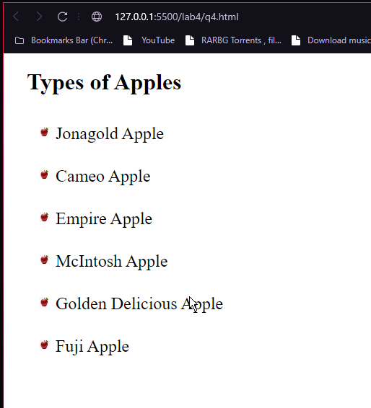

**LAB-5**

**Q1. Write a program to take an image, and make it 90% transparent on hover.**

<!DOCTYPE html>

<html lang="en">

<head>

    <meta charset="UTF-8">

    <meta http-equiv="X-UA-Compatible" content="IE=edge">

    <meta name="viewport" content="width=device-width, initial-scale=1.0">

    <title>Transparency</title>

    <style>

        img{

            margin-left: 10rem;

        }

        img:hover{

            opacity: 0.9;

        }

    </style>

</head>

<body>

    <img src="./gehu-dehradun.jpg" alt="">

</body>

</html>

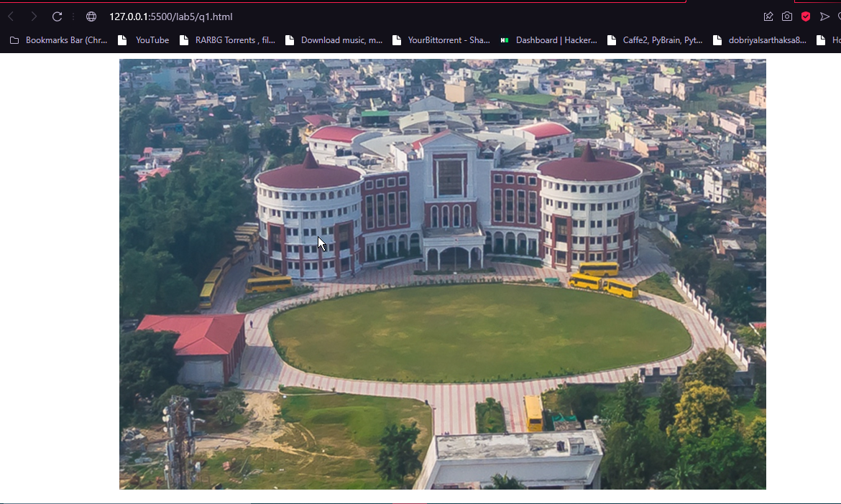

**Q2. Write a program to take two div’s of size 50px by 50px, and move them diagonally in opposite directions within a div of size 500px by 500px.**

<!DOCTYPE html>

<html lang="en">

<head>

    <meta charset="UTF-8">

    <meta http-equiv="X-UA-Compatible" content="IE=edge">

    <meta name="viewport" content="width=device-width, initial-scale=1.0">

    <title>Something</title>

    <style>

        .container{

            margin-left: 25rem;

            background-color: blueviolet;

            width: 500px;

            height: 500px;

        }

        #first,#second{

            width: 50px;

            height: 50px;

            background-color: black;

            position: relative;

        }

        #first{

            top: 0px;

            left: 0px;

        }

        #second{

            top: 400px;

            left: 450px;

        }

    </style>

</head>

<body>

    <div class="container">

        <div id="first"></div>

        <div id="second"></div>

    </div>

</body>

</html>

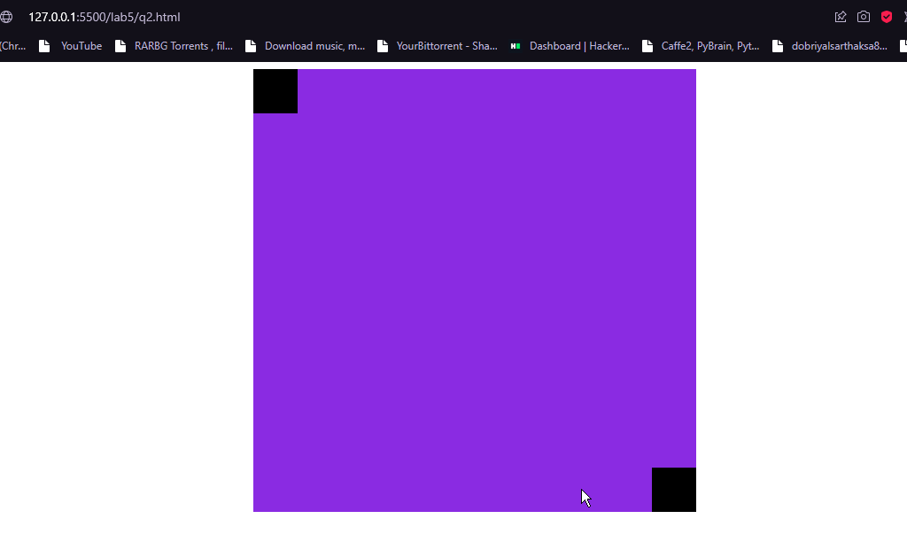

**Q3. Write a program to change the height and width of the div of size 100px by 100px to 200px by 200px and rotate it by 360 degrees on hover.**

<!DOCTYPE html>

<html lang="en">

<head>

    <meta charset="UTF-8">

    <meta http-equiv="X-UA-Compatible" content="IE=edge">

    <meta name="viewport" content="width=device-width, initial-scale=1.0">

    <title>lab5</title>

</head>

<style>

    div{

        background-color: lawngreen;

        width: 100px;

        height: 100px;

        margin-left: 35rem;

        transition: 01s ease-in;

    }

    div:hover{

        width: 200px;

        height: 200px;

        transform: rotate(360deg);

    }

</style>

<body>

    <div></div>

</body>

</html>

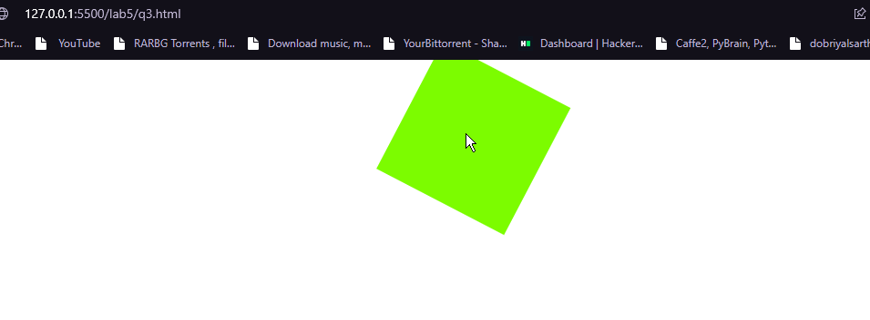

**Q4. Write a program to move a div of size 100px by 100px, from the top, a distance of 300px downwards, in such a manner that it should retain the style given by the last keyframe.**

<!DOCTYPE html>

<html lang="en">

<head>

    <meta charset="UTF-8">

    <meta http-equiv="X-UA-Compatible" content="IE=edge">

    <meta name="viewport" content="width=device-width, initial-scale=1.0">

    <title>Move</title>

    <style>

        div {

            width: 100px;

            height: 100px;

            margin-left: 35rem;

            background-color: lightcoral;

            animation-name: move;

            animation-duration: 4s;

            position: relative;

        }

        @keyframes move {

            0% {

                top: 0px

            }

            50% {

                top: 150px;

            }

            100% {

                top: 300px;

            }

        }

    </style>

</head>

<body>

    <div></div>

</body>

</html>

**1.**

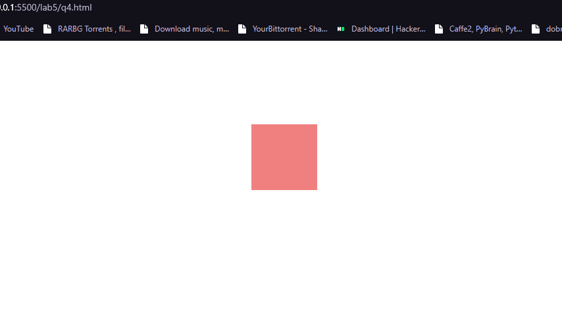

**2.**

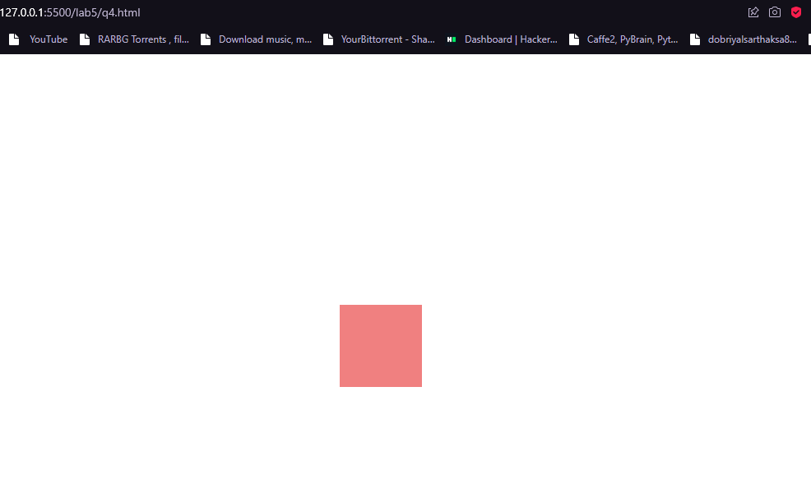

**Q5. Write a program to make an animation in which a smaller circle(background-color:red) will transform into a bigger circle(background-color:yellow). Also change it’s background color to orange on 50% complete.**

<!DOCTYPE html>

<html lang="en">

<head>

    <meta charset="UTF-8">

    <meta http-equiv="X-UA-Compatible" content="IE=edge">

    <meta name="viewport" content="width=device-width, initial-scale=1.0">

    <title>Animation</title>

</head>

<style>

    div{

        margin: 10rem 20rem;

        width: 100px;

        height: 100px;

        border-radius: 50%;

        background-color: red;

        animation: jaadu 4s  3 ;

    }

    @keyframes jaadu {

        50% {width: 200px; height: 200px; background-color: orange;}

        100% {width: 400px; height: 400px; background-color: red;}

    }

</style>

<body>

    <div></div>

</body>

</html>

1. 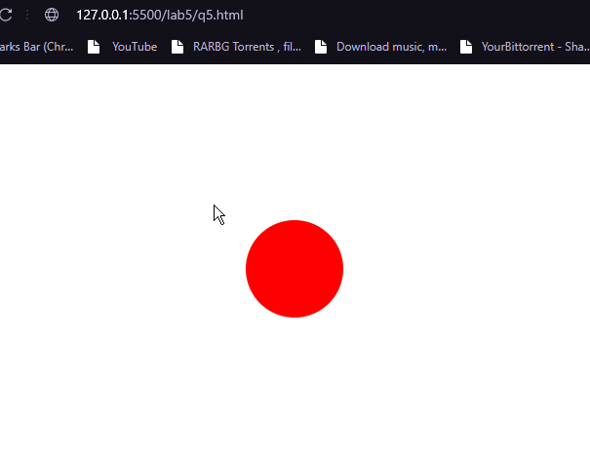

**2.**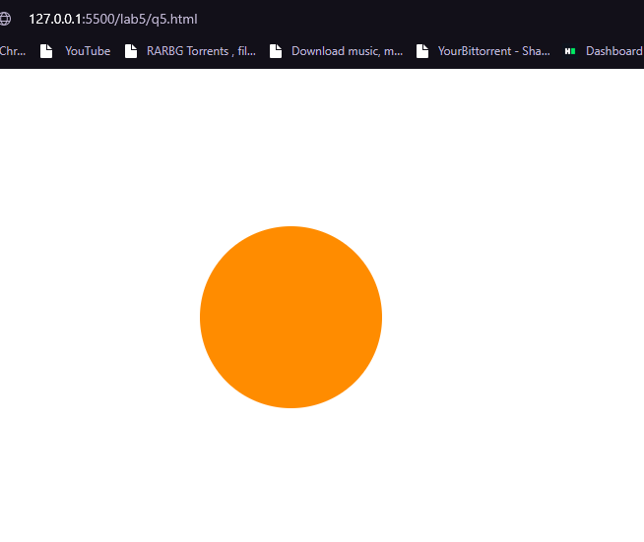

**3.**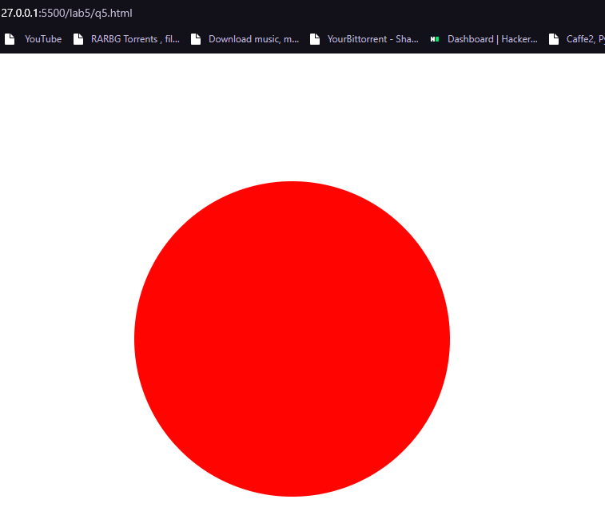

**LAB-6**

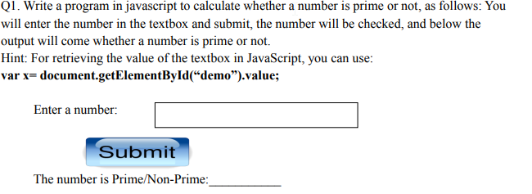

<!DOCTYPE html>

<html lang="en">

<head>

    <meta charset="UTF-8">

    <meta http-equiv="X-UA-Compatible" content="IE=edge">

    <meta name="viewport" content="width=device-width, initial-scale=1.0">

    <title>Prime Number</title>

    <style>

        div{

            margin: 5rem 15rem;

        }

        h2{

            font-size: 2.5rem;

            display: inline;

        }

        input{

            width: 15rem;

            padding: 1rem;

            outline: none;

            font-size: 1rem;

            font-weight: bolder;

        }

        button{

            padding: 1rem 2rem;

            font-size: 1.5rem;

            margin: 1rem;

            border: none;

            outline: none;

            color :white;

            background-color: lightslategray;

            border-radius: 30px;

            text-shadow: 2px 2px black  ;

            box-shadow: 5px 5px black;

        }

        button:hover{

            opacity: 0.7;

        }

        button:active{

            transform: translateY(4px);

            box-shadow: 2px 2px black;

        }

        h3{

            margin: 2rem 27rem;

            font-size: 2rem;

        }

    </style>

</head>

<body>

    <div>

        <h2>Enter a Number: </h2>

        <input type="number" id="num">

        <button>Submit</button>

    </div>

    <h3></h3>

    <script>

        let btn = document.querySelector("button");

        let h3 = document.querySelector("h3")

        btn.addEventListener("click", (e)=>{

            let input = document.querySelector("input");

            let num = input.value;

            if(isPrime(num)){

                h3.innerHTML = `${num} is a Prime Number`;

            }else{

                h3.innerHTML = `${num} is  Not a Prime Number`;

            }

        });

        function isPrime(num){

            if(num == 1){

                return false;

            }

            for(let i = 2;i<=Math.sqrt(num);i++){

                if(num % i == 0){

                    return false;

                }

            }

            return true;

        }

    </script>

</body>

</html>

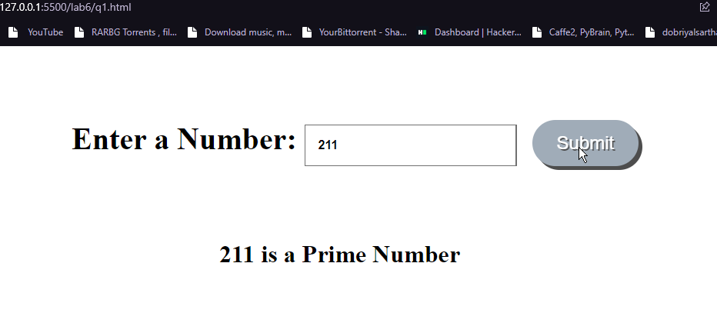

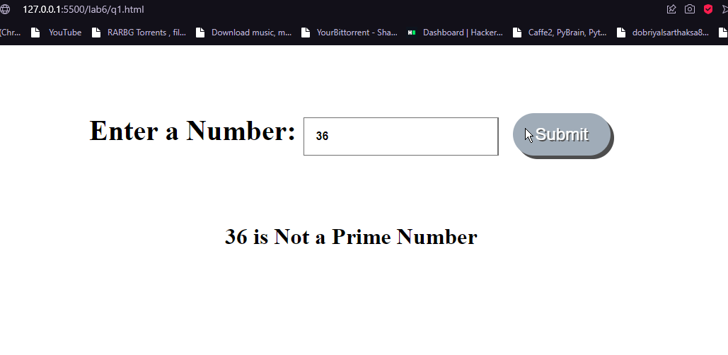

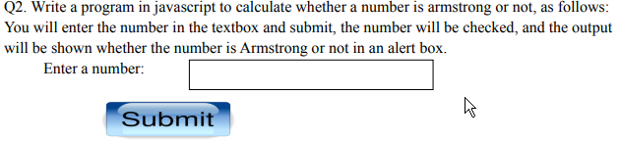

<!DOCTYPE html>

<html lang="en">

<head>

    <meta charset="UTF-8">

    <meta http-equiv="X-UA-Compatible" content="IE=edge">

    <meta name="viewport" content="width=device-width, initial-scale=1.0">

    <title>Prime Number</title>

    <style>

        div {

            margin: 5rem 15rem;

        }

        h2 {

            font-size: 2.5rem;

            display: inline;

        }

        input {

            width: 15rem;

            padding: 1rem;

            outline: none;

            font-size: 1rem;

            font-weight: bolder;

        }

        button {

            padding: 1rem 3rem;

            font-size: 1.5rem;

            color: white;

            margin: 1rem;

            border: none;

            outline: none;

            background-color: lightslategray;

            border-radius: 30px;

            text-shadow: 2px 2px black ;

            box-shadow: 5px 5px black;

        }

        button:hover {

            opacity: 0.7;

        }

        button:active {

            transform: translateY(4px);

            box-shadow: 0px 0px ;

        }

        h3 {

            margin: 2rem 27rem;

            font-size: 2rem;

        }

    </style>

</head>

<body>

    <div>

        <h2>Enter a Number: </h2>

        <input type="number" id="num">

        <button>Submit</button>

    </div>

    <h3></h3>

    <script>

        let btn = document.querySelector("button");

        let h3 = document.querySelector("h3")

        btn.addEventListener("click", (e) => {

            let input = document.querySelector("input");

            let num = input.value;

            if (isArmstrong(num)) {

                h3.innerHTML = `${num} is an Armstrong Number`;

            } else {

                h3.innerHTML = `${num} is  Not an Armstrong Number`;

            }

        });

        function isArmstrong(number) {

            let sum = 0;

            let temp = number;

            while (temp > 0) {

                let remainder = temp % 10;

                sum += remainder * remainder * remainder;

                temp = parseInt(temp / 10);

            }

            if (sum == number) {

                return true;

            }

            return false;

        }

    </script>

</body>

</html>

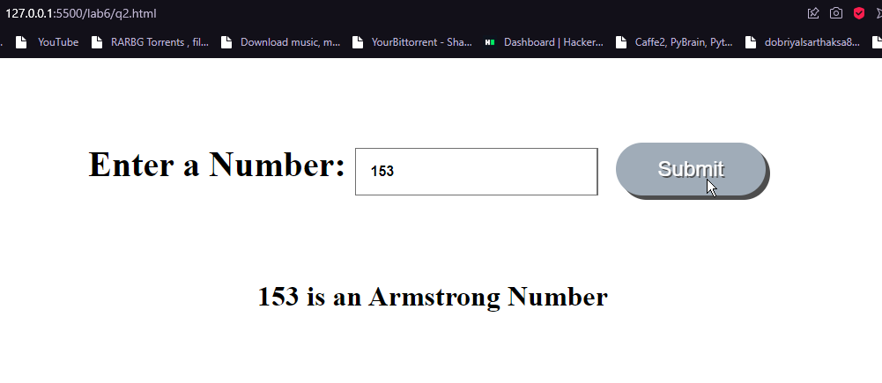

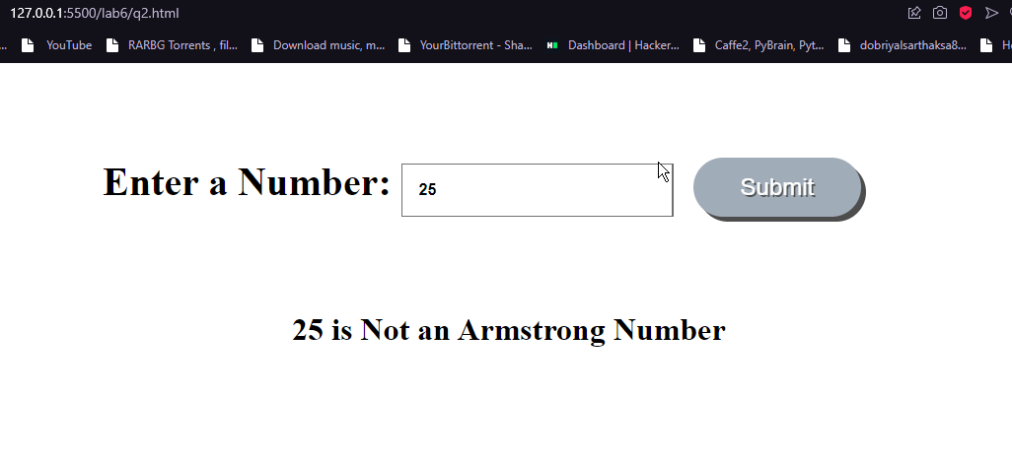

**Q3. Calculate the factorial of a number using a prompt box. Prompt the user to enter a number, and then calculate it’s factorial and display on the screen**

<!DOCTYPE html>

<html lang="en">

<head>

    <meta charset="UTF-8">

    <meta http-equiv="X-UA-Compatible" content="IE=edge">

    <meta name="viewport" content="width=device-width, initial-scale=1.0">

    <title>Prompt</title>

</head>

<body>

    <h1></h1>

    <script>

        let num = window.prompt("Enter a Number");

        let fact = factorial(num);

        let h1 = document.querySelector("h1");

        h1.innerHTML = `${num}! = ${fact}`;

        function factorial(num){

            let fact = 1;

            for(let i=1;i<=num;i++){

                fact = fact*i;

            }

            return fact;

        }

    </script>

</body>

</html>

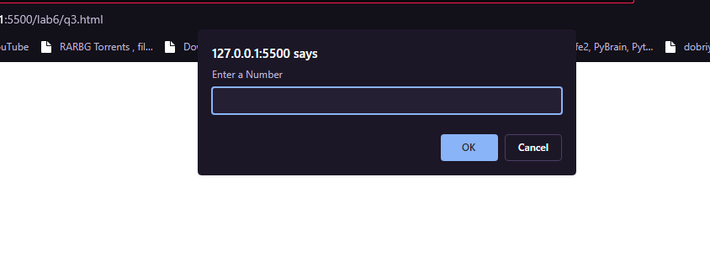

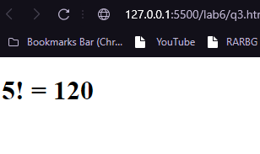

**Q4. Think of the way you can use confirm box in javascript in real world. Write an innovative program to show it.**

<!DOCTYPE html>

<html lang="en">

<head>

    <meta charset="UTF-8">

    <meta http-equiv="X-UA-Compatible" content="IE=edge">

    <meta name="viewport" content="width=device-width, initial-scale=1.0">

    <title>Confirm Box</title>

</head>

<body>

    <h1></h1>

    <script>

        let human = window.confirm("Are you Human");

        let h1 = document.querySelector("h1");

        if(human){

            h1.innerHTML = "Bravooo!!!!!"

        }else{

            h1.innerHTML = "Alassss!!!!!!!"

        }

    </script>

</body>

</html>



**On pressing ok:**



**On pressing cancel:**



**Q5. Take a javacsript variable, containing “Hello World!!”. Write a program in Javacsript, so that now that variable contains “Hello World!! Have a nice day!!”.**

<!DOCTYPE html>

<html lang="en">

<head>

    <meta charset="UTF-8">

    <meta http-equiv="X-UA-Compatible" content="IE=edge">

    <meta name="viewport" content="width=device-width, initial-scale=1.0">

    <title>Kuch to Hai</title>

</head>

<body>

    <script>

        var x = "Hello World!!"

        x= "Hello World!! Have a nice day!!"

    </script>

</body>

</html>

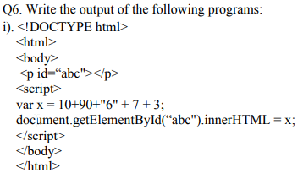

**Ans: *100673***

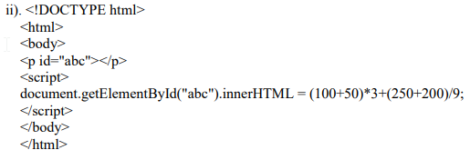

**Ans: *500***

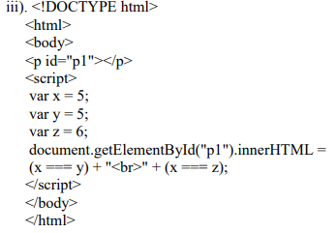

**Ans: *true***

***false***